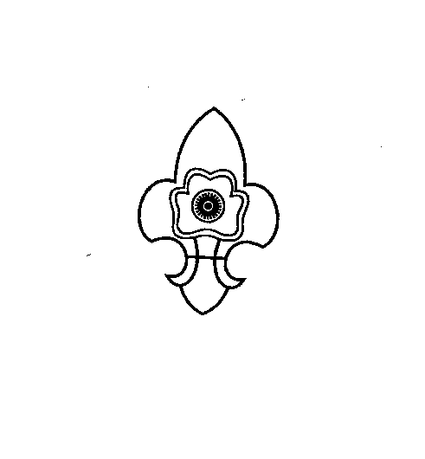
THE MEGHALAYA BHARAT SCOUTS & GUIDES

“Empowering the Youth, Powering the Nation”
STATE HEADQUARTERS::: PINEMOUNT-RIDGE
SHILLONG - 1.
Phone No & Fax No: (0364) 2226197
www.megscoutguide.nic.in
Email: mbsg_meghalaya@yahoo.co.in & meghalayascoutsandguides@gmail.com

No: MBSG/BSG Flag/2020/ Date: 30th October 2020

To
All Commissioners, Unit Leaders
Rovers/Rangers and MSGF Members
Meghalaya Bharat Scouts and Guides
Shillong.

Subject: Meghalaya Bharat Scouts and Guides Awareness Week to commemorate the Annual Foundation Day on the 7th November, 2020.

Sir/Madam,
It is with immense pleasure to inform you that the Meghalaya Bharat Scouts and Guides will be celebrating the “Meghalaya Bharat Scouts and Guides Awareness Week” from the 3rd to 7th November 2020 in celebration of the Foundation Day which is on the 7th November 2020 with the theme “MBSG Fights Covid-19”.
Therefore, in this regard a one week awareness programme will be held at different locations of East Khasi Hills District.
The details of the weekly programme are as follows:
- 3rd November, 2020 (Day 1) – Inauguration, Route March and Flash Mob at Police Bazar.
- 4th November, 2020 (Day 2) – Flash mob at Smit.
- 5th November, 2020 (Day 3) – Flash mob at Mylliem
- 6th November, 2020 (Day 4) – Online Covid19 Awareness Webinar.
- 7th November, 2020 (Day 5) – Foundation Day Celebration at the State Headquarters.
- Slogan and Poster competition on the said theme will be held virtually by posting on Social Media with the hash tag #MBSGFightsCovid19 and results will be announced on the 7th November, 2020.

N.B: Final programme will be intimated later

With Regards
Yours Sincerely

(Mrs. A. Swer)
State Secretary
MBSG, Shillong

